Israel Tour – March 3-14, 2025

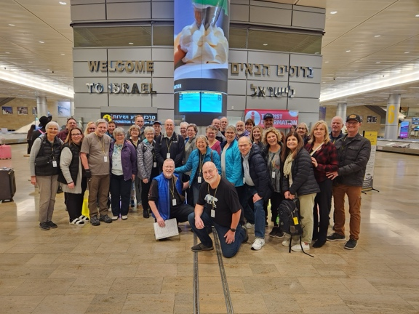
Who is leading the tour?
Pastor Al (retired)
For over 40 years Al & Susie Hester have been in full time Christian ministry including six years serving as missionaries in Ukraine. Their heart is to help people know and love Jesus Christ. Four years ago, Al & Susie traveled to Israel with GTI Tours.
“Faith Igniting” is a good phrase to describe what happened.
Now our desire is to help others have that same faith igniting experience in the land where God laid out His plan for redemption and where Jesus walked. More than just a sightseeing tour, this study tour will introduce you to the geography, culture, and history of the Holy Land. Our prayer is that God will use this tour to deepen your understanding, faith, and joy as you discover Israel in living color.

GTI Study Tours
GTI Tours is a Christian owned and operated full-service tour company specializing in ministry travel since 1992. GTI has facilitated over 500 Biblical study tours to Israel, Turkey, Greece, Jordan, and Egypt. GTI offers all-inclusive guided trips that bring Scripture to life through a first-hand encounter with the land and lessons of the Bible. GTI’s local travel specialists, international ground support staff, drivers and guides are some of the world's best in providing courteous, knowledgeable, professional services. All the details are handled with great care to ensure a memorable experience. GTI’s mission is to bring honor to God by using their travel expertise to facilitate life-changing experiences for study tour participants. The tours are designed to give participants a true understanding of the land and the culture in which the Bible was written. Itineraries are designed to enhance faith lessons, combining cultural history with biblical teaching and scriptural importance.
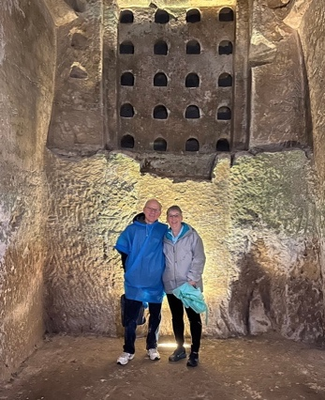
Our trip to Israel in 2023 with Al & Susie was a highlight of our lives. We were blessed to go with such great people and GTI tours was absolutely fantastic. Everything was set up to be able to experience the land of the Bible and bring it to life. Al’s meditations at the sites added to the depth of the experience. How exciting to open our Bible and read about a place where it actually happened! This is something that every Christian should participate in – you’ll never read your Bible in the same way. Larry & Candie
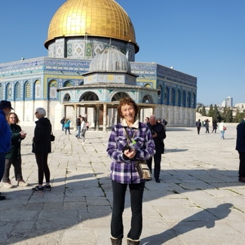
Al & Susie’s Israel tour has had such a profound effect on my life. Every time I read or hear the Bible, memories of the places we visited flood back to my mind. The historical background our extremely knowledgeable Israeli guide gave us and the fellowship we all enjoyed as we explored God’s promised land were such a blessing. The tour was run so smoothly. All we had to do was enjoy and absorb it all. I would go on this tour again in a heartbeat. Carol

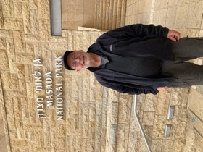
Being in Israel exceeded my expectations. The country is definitely one of contrasts. As a student of geography and history, everything came alive. All the Bible stories told me from childhood went from two dimensional to three dimensional. My senses were definitely heightened. Walking where Christ walked or where David took refuge from Saul. Riding a boat on the Sea of Galilee to eating fish from that very source. My greatest impression was that Israel felt like home! Word of advice to anyone contemplating a trip to Israel, DO IT NOW. Phil
Itinerary (subject to change)

Day | Area | Sites
Monday - Tuesday  March 3-4 | Travel | Depart Dulles on Mon, Mar 3 at 6:05pm (Lufthansa)  Arrive Frankfurt on Tue, Mar 4 at 7:45am (7 hours 40 minutes)  Depart Frankfurt on Tue, Mar 4 at 2:30pm (Lufthansa)  Arrive Tel Aviv on Tue, Mar 4 at 7:35pm (4 hours 5 minutes)  Overnight - Neve Ilan Hotel, near Jerusalem
Wednesday  March 5 | Shephelah | Beth Shemesh, Azekah, Beth Guvrin (Maresha), Beersheba  Dinner & Overnight Isrotel Ganim Hotel, Dead Sea
Thursday  March 6 | Negev | Masada, Bedouin Hospitality, Tel Arad, Dead Sea  Dinner & Overnight Isrotel Ganim Hotel, Dead Sea
Friday  March 7 | Rift Valley | Ein Gedi, Qumran , Lower Jordan  Dinner & Overnight Ein Gev Kibbutz, Galilee
Saturday  March 8 | Galilee | Mount Arbel, Magdala, Tabgha, Capernaum, Chorazin, Mount of Beatitudes, Ancient Boat (Ginosar), Galilee Boat Ride  Dinner & Overnight Ein Gev Kibbutz, Galilee
Sunday  March 9 | Upper  Galilee | Katzrin (cultural experience), Mount Bental, Caesarea Philippi, Tel Dan  Dinner & Overnight Ein Gev Kibbutz, Galilee
Monday  March 10 | Lower  Galilee | Beth Shean, Church of Annunciation, Megiddo, Caesarea Maritima  Dinner & Overnight Dan Hotel, Jerusalem
Tuesday  March 11 | Jerusalem | Temple Mount, Western Wall, Rabbinic Tunnels, Herodium, Church of the Nativity, Bethlehem  Dinner & Overnight Dan Hotel, Jerusalem
Wednesday  March 12 | Jerusalem | City of David, Hezekiah's Tunnel, Pilgrim’s Road, Southern Steps, Israel Museum, Model of Jerusalem, Shrine of the Book, Yad Vashem  Dinner & Overnight Dan Hotel, Jerusalem
Thursday  March 13 | Jerusalem | Mount of Olives, Gethsemane, Saint Anne's, Pool of Bethesda, Via Dolorosa, Church of the Holy Sepulchre, Farewell Dinner  Overnight Only Dan Hotel , Jerusalem
Friday  March 14 | Travel | Depart Tel Aviv on Fri, Mar 14 at 5:20am (Swiss Air)  Arrive Zurich Airport on Fri, Mar 14 at 8:40am (4 hours 20 minutes)  Depart Zurich Airport on Fri, Mar 14 at 12:55pm (Swiss Air)  Arrive Dulles on Fri, Mar 14 at 5:25pm (9 hours 30 minutes)

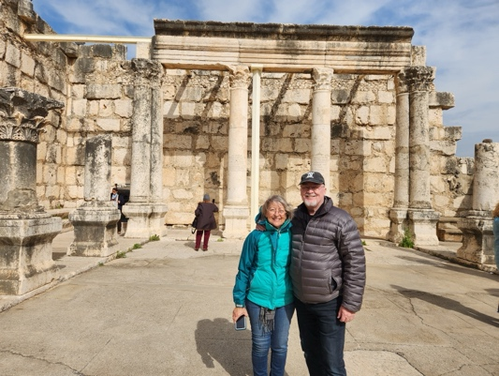
Sounds great, but is it safe?
Al & Susie Hester
- If it is truly unsafe, GTI will cancel the tour and work to recover and reimburse as much of the costs as possible. GTI encourages the purchase of trip insurance.
- Remember that our media “plays up” the situation in Israel to “make news”. Life in Israel usually goes on normally. Pray for the war to end!
- GTI, in cooperation with the Israeli tour ministry, monitors events daily and will never take a tour into an unsafe situation.
- Life involves risk. The benefits of walking The Land far outweigh any risks.

Recommended news and ministry websites...
timesofisrael.com / allisrael.com / oneforisrael.org

Contact information...
Al & Susie Hester / hesters@hesters.org / 619.733.5214
Tour Pricing
- $5,290 per person double occupancy. ($1400 additional for single occupancy)
- $100 early booking discount for registrations prior to September 9, 2024
- GTI will decrease the cost of the trip by $832 per person for those who make their own travel arrangements. This is called air credit.

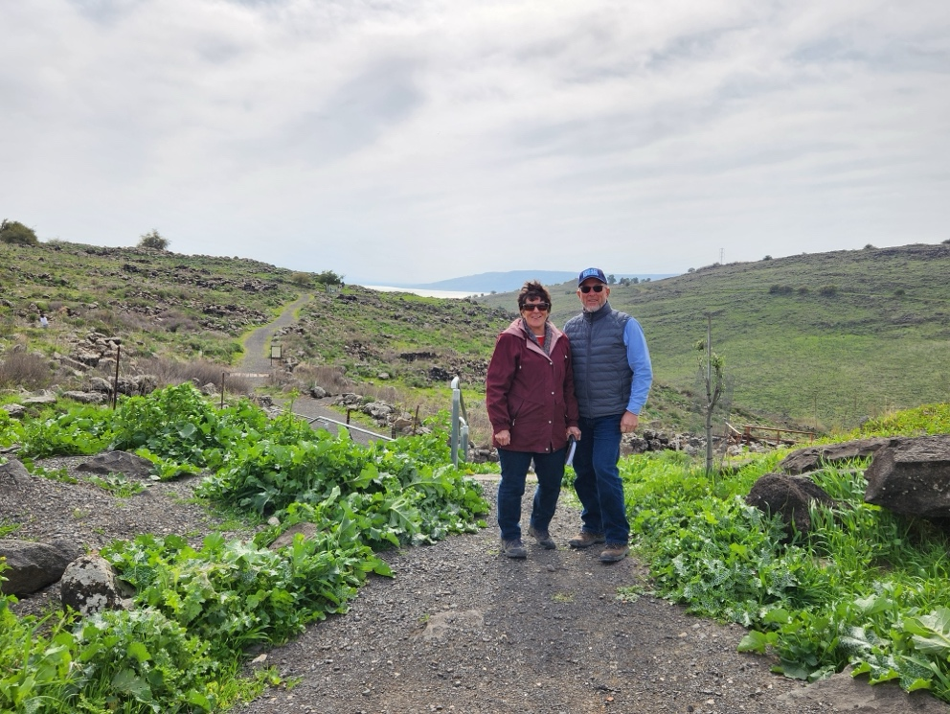
Cost Includes
- Airfare from/to Dulles (economy class)
- Deluxe Hotels - Buffet breakfast and dinner daily
- Lunches served on site.
- Deluxe motor coach touring
- Hydration backpack with bottled water on tour
- All transfers, porterage, entrance fees and taxes
- Guide and driver tips.
- Study guides, journals.
- GTI Blog
- Pre trip curriculum
Chorizin, Sea of Galilee
Mel & Priscilla Sayer
Cost Does Not Include
- Extra ordered drinks with meals
- Optional Travel Insurance (Learn more at https://gtitours.org/travel-insurance)
- NOTE: Air fare is subject to fuel surcharges as may be assessed by the airline prior to ticketing.

Payment Schedule
- $500 per person deposit due after registration to hold your reservation.
- Balance payable in two payments. $2,395 due October 2024. Balance due January 10, 2025.
- NOTE: GTI accepts checks only (no credit cards)

Refund Cancellation Policy:
- Full refund less $200 for cancellations after deposit.
- Full refund less $500 for cancellations after September 9, 2024
- Full refund less $2000 for cancellations after October 14, 2024
- No refunds for cancellations after January 10, 2025

How to Register:
- Go to https://gtitours.org/trip/hester25 and click on the “Register Now” link.
- When you register
  - You will need your passport information (can be sent later but better sooner than later)
  - You will be able to indicate any medical or diet restrictions.
  - You will need to send in your $500 per person deposit right away.
- Within a few days of registering, you will receive an email from GTI directing you how to create your own account (for each person).
- Check into and consider purchasing travel insurance (optional).
- Make sure to investigate all the excellent information and videos available on the www.GTItours.org

